Networking Commands

1. OSPF :
Open Shortest Path First (OSPF) is a link-state routing protocol that was developed for IP networks and is based on the Shortest Path First (SPF) algorithm. OSPF is an Interior Gateway Protocol (IGP).

What is used for ?
Used to distribute IP routing information throughout a single Autonomous System (AS) in an IP network.

Commands:

a. show ip ospf border-routers

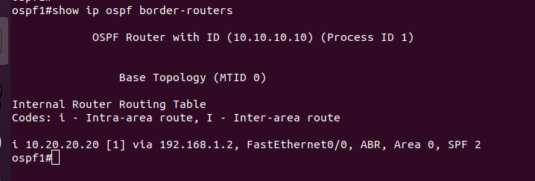
Details :
10.20.20.20 - Router ID of the destination.
[1] - Cost of using this route.
Via 192.168.1.2 - Next hop toward the destination.
FastEthernet0/0 - Interface type for the outgoing interface.
ABR - The router type of the destination; it is either an ABR or ASBR or both.
Area - The area ID of the area from which this route is learned.
SPF - The internal number of the shortest path first (SPF) calculation that installs this route.

b. show ip ospf interface
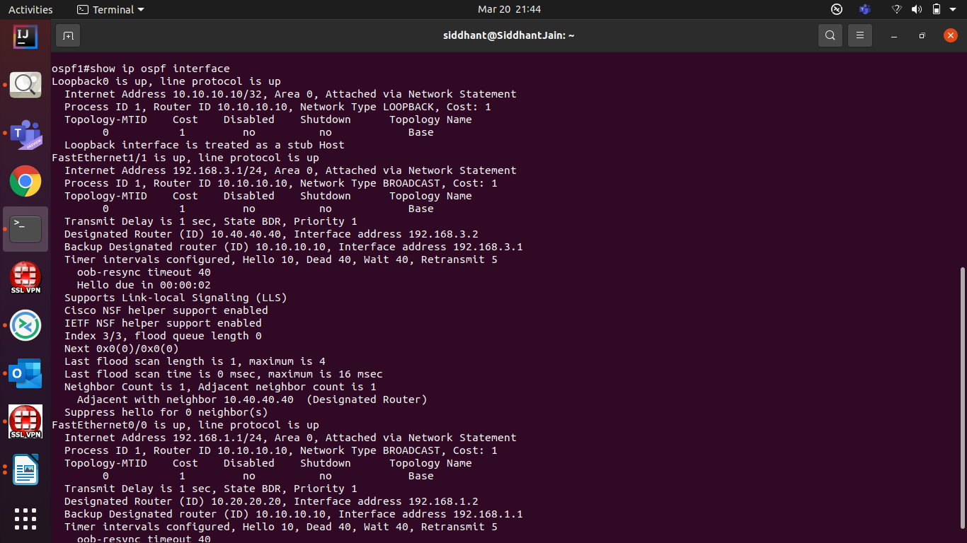
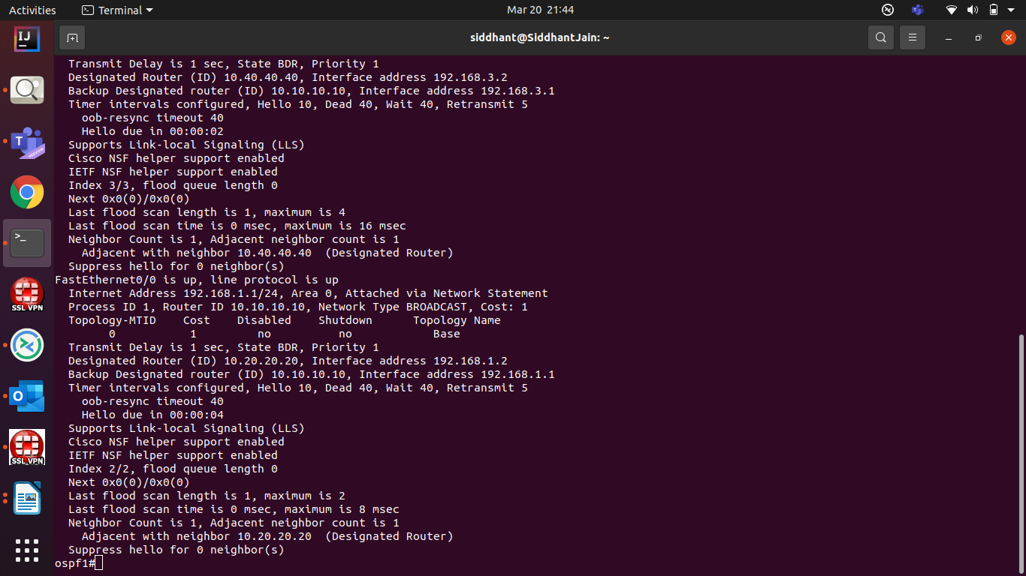
Details:
show ip [ospf][process-id] interface [ type number ] [brief][multicast][topology{topology-name | base} ]

Syntax Description

process-id | (Optional) Process ID number. If this argument is included, only information for the specified routing process is included. The range is 1 to 65535.
type | (Optional) Interface type. If thetype argument is included, only information for the specified interface type is included.
number | (Optional) Interface number. If the number argument is included, only information for the specified interface number is included.
brief | (Optional) Displays brief overview information for OSPF interfaces, states, addresses and masks, and areas on the device.
multicast | (Optional) Displays multicast information.
topologytopology-name | (Optional) Displays OSPF-related information about the named topology instance.
topology base | (Optional) Displays OSPF-related information about the base topology.

Explanation
Field | Description
Loopback0,FastEthernet0/0 | Status of the physical link and operational status of the protocol.
Process ID | OSPF process ID.
Area | OSPF area.
Cost | Administrative cost assigned to the interface.
State | Operational state of the interface.
Nbrs F/C | OSPF neighbor count.
Internet Address | Interface IP address, subnet mask, and area address.
Topology-MTID | MTR topology Multitopology Identifier (MTID). A number assigned so that the protocol can identify the topology associated with information that it sends to its peers.
Transmit Delay | Transmit delay in seconds, interface state, and device priority.
Designated Router | Designated router ID and respective interface IP address.
Backup Designated router | Backup designated router ID and respective interface IP address.
Timer intervals configured | Configuration of timer intervals.
Hello | Number of seconds until the next hello packet is sent out this interface.
Strict TTL checking enabled | Only one hop is allowed.
Strict TTL checking enabled, up to 4 hops allowed | A set number of hops has been explicitly configured.
Neighbor Count | Count of network neighbors and list of adjacent neighbors.

c. show ip ospf interface brief

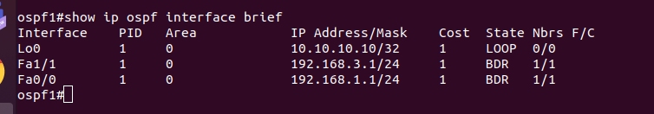
Details : upar vala output hi h format way me

d. show ip ospf neighbor

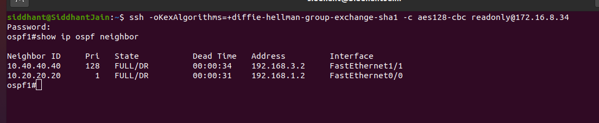

Details :
Field | Description
Neighbor | Neighbor router ID.
interface address | IP address of the interface.
In the area | Area and interface through which the OSPF neighbor is known.
Neighbor priority | Router priority of the neighbor and neighbor state.
State | OSPF state. If one OSPF neighbor has enabled TTL security, the other side of the connection will show the neighbor in the INIT state.
state changes | Number of state changes since the neighbor was created. This value can be reset using the clear ip ospf counters neighbor command.
DR is | Router ID of the designated router for the interface.
BDR is | Router ID of the backup designated router for the interface.
Options | Hello packet options field contents. (E-bit only. Possible values are 0 and 2; 2 indicates area is not a stub; 0 indicates area is a stub.)
LLS Options..., last OOB-Resync | Link-Local Signaling and out-of-band (OOB) link-state database resynchronization performed hours:minutes:seconds ago. This is nonstop forwarding (NSF) information. The field indicates the last successful out-of-band resynchronization with the NSF-capable router.
Dead timer due in | Expected time in hours:minutes:seconds before Cisco IOS software will declare the neighbor dead.
Neighbor is up for | Number of hours:minutes:seconds since the neighbor went into the two-way state.
Index | Neighbor location in the area-wide and autonomous system-wide retransmission queue.
retransmission queue length | Number of elements in the retransmission queue.
number of retransmission | Number of times update packets have been re-sent during flooding.
First | Memory location of the flooding details.
Next | Memory location of the flooding details.
Last retransmission scan length | Number of link state advertisements (LSAs) in the last retransmission packet.
maximum | Maximum number of LSAs sent in any retransmission packet.
Last retransmission scan time | Time taken to build the last retransmission packet.
maximum | Maximum time, in milliseconds, taken to build any retransmission packet.

Reference : https://www.cisco.com/c/en/us/td/docs/ios-xml/ios/iproute_ospf/command/iro-cr-book/ospf-s1.html#wp3042193830

2. BGP :
Border Gateway Protocol (BGP) is a standardized exterior gateway protocol designed to exchange routing and reachability information between autonomous systems (AS) on the Internet. The protocol is often classified as a path vector protocol but is sometimes also classed as a distance-vector routing protocol.

What is used for ?
used to Exchange routing information for the internet and is the protocol used between ISP which are different ASes.

What is AS?
An Autonomous System (AS) is a set of Internet routable IP prefixes belonging to a network or a collection of networks that are all managed, controlled and supervised by a single entity or organization.

What is ASN?

Autonomous System Number (ASN) is a globally unique identifier that defines a group of one or more IP prefixes run by one or more network operators that maintain a single, clearly-defined routing policy. These groups of IP prefixes are known as autonomous systems.

Commands:

a. show bgp all
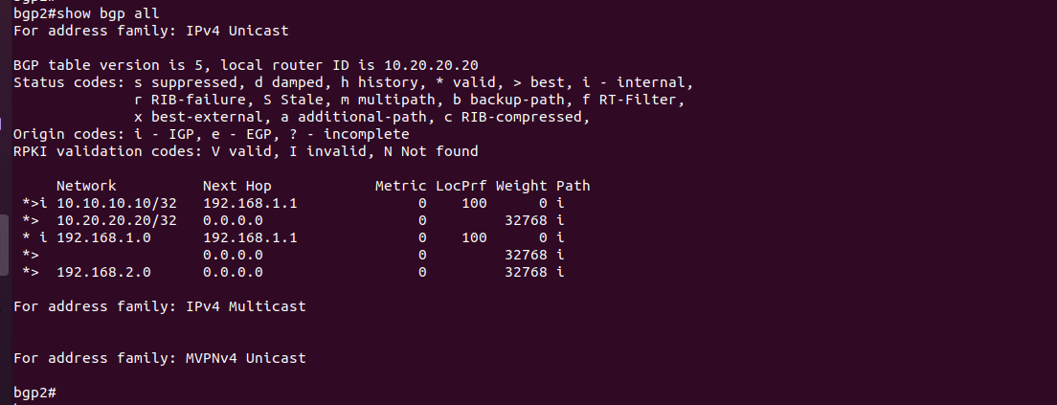
Details :
Metric – lowest will be best path
LocPrf – Local preference , more will be consider as best path
Weight – High is the best

b. show ip bgp

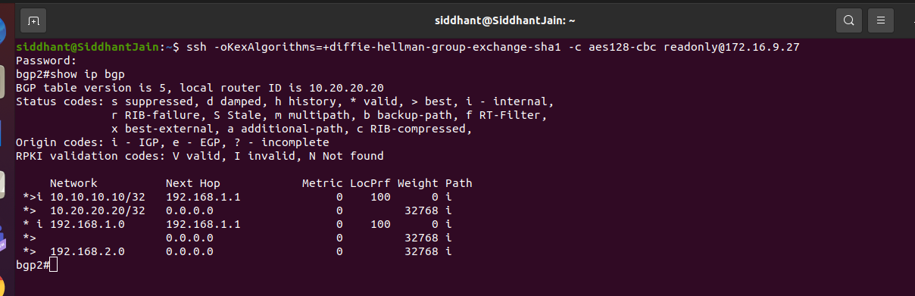
Details:

Field | Description
BGP table version | Internal version number of the table. This number is incremented whenever the table changes.
local router ID | IP address of the router.
Status codes | Status of the table entry. The status is displayed at the beginning of each line in the table. It can be one of the following values:  - s—The table entry is suppressed.  - d—The table entry is dampened.  - h—The table entry history.  - *—The table entry is valid.  - >—The table entry is the best entry to use for that network.  - i—The table entry was learned via an internal BGP (iBGP) session.  - r—The table entry is a RIB-failure.  - S—The table entry is stale.  - m—The table entry has multipath to use for that network.  - b—The table entry has a backup path to use for that network.  - x—The table entry has a best external route to use for the network.
Origin codes | Origin of the entry. The origin code is placed at the end of each line in the table. It can be one of the following values:  - a—Path is selected as an additional path.  - i—Entry originated from an Interior Gateway Protocol (IGP) and was advertised with a network router configuration command.  - e—Entry originated from an Exterior Gateway Protocol (EGP).  - ?—Origin of the path is not clear. Usually, this is a router that is redistributed into BGP from an IGP.
RPKI validation codes | If shown, the RPKI validation state for the network prefix, which is downloaded from the RPKI server. The codes are shown only if the bgp rpki server or neighbor announce rpki state command is configured.
Network | IP address of a network entity.
Next Hop | IP address of the next system that is used when forwarding a packet to the destination network. An entry of 0.0.0.0 indicates that the router has some non-BGP routes to this network.
Metric | If shown, the value of the interautonomous system metric.
LocPrf | Local preference value as set with the set local-preference route-map configuration command. The default value is 100.
Weight | Weight of the route as set via autonomous system filters.
Path | Autonomous system paths to the destination network. There can be one entry in this field for each autonomous system in the path.
(stale) | Indicates that the following path for the specified autonomous system is marked as “stale” during a graceful restart process.
Updated On | The time at which the path is received or updated.

Reference : https://www.cisco.com/c/en/us/td/docs/ios-xml/ios/iproute_bgp/command/irg-cr-book/bgp-s1.html#wp1745539073

IS-IS:
The IS-IS protocol is an interior gateway protocol (IGP) that uses link-state information to make routing decisions. IS-IS is a link-state IGP that uses the shortest-path-first (SPF) algorithm to determine routes.

What is used for?
Used to distribute IP routing information throughout a single Autonomous System (AS) in an IP network.

How it is different from OSPF ?
OSPF supports NBMA and point-to-multipoint links, whereas IS-IS does not support. IS-IS runs on the data link layer, whereas OSPF runs on the network layer. OSPF supports virtual links, whereas IS-IS does not support.

Command :

a. show isis neighbor

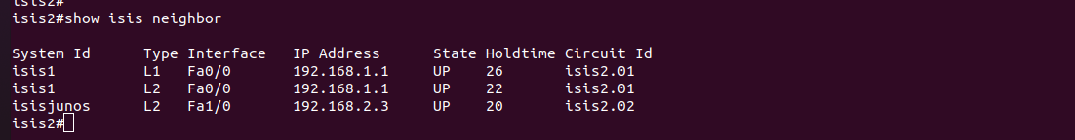
use to get more deatils - show isis neighbors detail
Details :

System id : Six-byte value that identifies a system in an area.
Type : Level type. Indicates whether the IS-ISneighbor is a Level 1, Level-1-2, or Level 2 device.
Interface : Interface Interface from which the system was learned.
IP Address : IP address of the neighbor device.
State : Indicates whether the state of the IS-IS neighbor is up or down.
Holdtime Link-state packet (LSP) holdtime. Amount of time that the LSPremains valid (in seconds).
Circuit Id : Port location for the IS-IS neighbor device that indicates how it is connected to the local device.
Area Address(es): Reachable area addresses from the device. For Level 1 LSPs, these are the area addresses configured manually on the originating device. For Level 2 LSPs, these are all the area addresses for the area to which this device belongs.

SNPA : Subnetwork point of attachment. This is the data-link address.
State Changed :State change.
LAN : Priority Priority of the LAN.
Remote TID : Neighbor device topology IDs.
Local TID :Local device topology IDs.

b. show isis topology
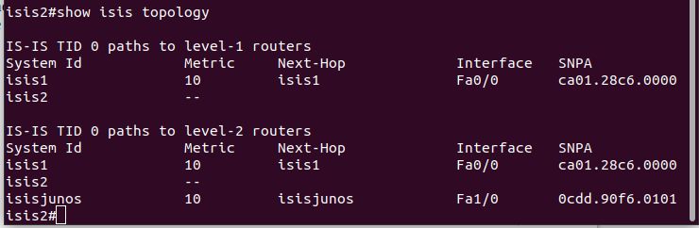
Details:
Tag : Identifies the routing process.
System Id : Six-byte value that identifies a system in an area.
Metric : IS-IS metric for the cost of the adjacency between the originating router and the advertised neighbor, or the metric of the cost to get from the advertising router to the advertised destination (which can be an IP address, an end system [ES], or a CLNS prefix).
Next-Hop : The address of the next hop router.
Interface : Interface from which the system was learned.
SNPA : Subnetwork point of attachment. This is the data-link address

References : https://www.cisco.com/c/en/us/td/docs/ios-xml/ios/iproute_isis/command/irs-cr-book.pdf

Mpls :
Multiprotocol Label Switching, or MPLS, is a networking technology that routes traffic using the shortest path based on “labels,” rather than network addresses, to handle forwarding over private wide area networks.

What is used for ?
MPLS can be used when speed and reliability are highly important.

Commands :
a. show mpls interfaces

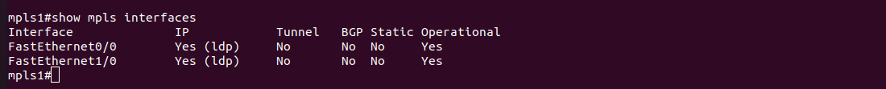

Field | Description
Interface | Interface name.
IP | "Yes" if IP label switching (sometimes called hop-by-hop label switching) has been enabled on this interface.
Tunnel | "Yes" if LSP tunnel labeling has been enabled on this interface.
Tagging operational | Operational state. "Yes" if labeled packets can be sent over this interface. Labeled packets can be sent over an interface if an MPLS protocol is configured on the interface and the required Layer 2 negotiations have occurred.

Reference : https://www.cisco.com/c/en/us/td/docs/switches/datacenter/sw/5_x/nx-os/mpls/command/reference/mpls_cmds_show.html

show ip interface brief

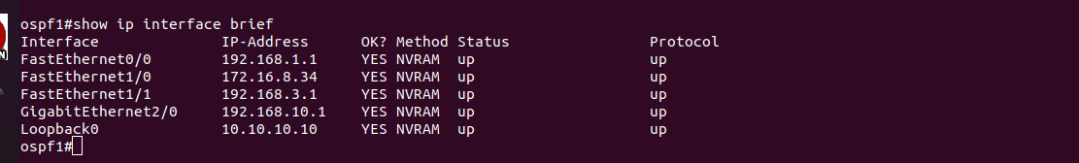
Deatils :
The show IP interface brief command gives you the answers to these questions and is the best summary of the status, protocol and IP addresses of your interfaces. This command can be used in both User EXEC and Privileged EXEC mode.
This command can be abbreviated sh ip int brie.
show interfaces description

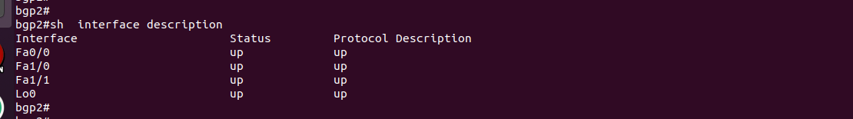

This command displays the status and configuration information for the ports within the switch.

VPN :
VPN protocols determine exactly how data is routed through a connection. These protocols have different specifications based on the benefits and desired circumstances; for example, some VPN protocols prioritize data throughput speed while others focus on masking or encrypting data packets for privacy and security.

LAN :
A local area network (LAN) consists of a series of computers linked together to form a network in a circumscribed location. The computers in a LAN connect to each other via TCP/IP ethernet or Wi-Fi. A LAN is normally exclusive to an organization

VLAN:
VLANs allow network administrators to automatically limit access to a specified group of users by dividing workstations into different isolated LAN segments. When users move their workstations, administrators don't need to reconfigure the network or change VLAN groups.

Ip Multicast :
IP multicast routing enables a host (source) to send packets to a group of hosts (receivers) anywhere within the IP network by using a special form of IP address called the IP multicast group address.

How does it work?
Multicast IP Routing protocols are used to distribute data (for example, audio/video streaming broadcasts) to multiple recipients. Using multicast, a source can send a single copy of data to a single multicast address, which is then distributed to an entire group of recipients

Juniper Networks designs and markets IT networking products, such as routers, switches and IT security products. It started out selling core routers for ISPs, and expanded into edge routers, data centers, wireless networking, networking for branch offices and other access and aggregation devices.

Juniper Networks provides high-performance network devices that create a responsive and trusted environment for accelerating the deployment of services and applications over a single network. The Junos operating system (Junos OS) is the foundation of these high-performance networks.

